|  |  |
| --- | --- |
| Website | Date |
| www.bytown.net/mcelroy.htm | Nov 11 2002 |
| www.bytown.net/gcraig.htm | July 28 2002 |
| www.bytown.net/oldfolks.htm | December 6, 2002: |
| www.bytown.net/waddell.htm | Jan 1 2003 |
| www.bytown.net/fitzpatw.htm | January 26, 2003 |
| www.bytown.net/pretoria.htm | Jan 31 2003 |
| www.bytown.net/orr.htm | Feb 11 2003 |
| www.bytown.net/graham.htm | Dec 29 2003 |
| www.bytown.net/movers.htm | Sept 3 2004 |
| www.bytown.net/riellyetc.htm | Sep 15 2004 |
| www.bytown.net/bellscor.htm | Feb 28 2005 |
| www.bytown.net/glashan.htm | Oct 19, 2005 |
| www.bytown.net/turgeonmayor.htm | April 13, 2006 |
| www.bytown.net/holiness.htm | Jul 25, 2007 |
| www.bytown.net/ottawacrest.htm | Apr 17 2008 |
| www.bytown.net/streetcars.htm | July 21 2008 |
| www.bytown.net/conlonpatrick.htm | February 24, 2009 |
| www.bytown.net/canalfrancophones.htm | Mar 20 2009 |
| http://www.bytown.net/mlhickey.htm | Mar 29 2009 |
| www.bytown.net/freepress.htm | Dec 24, 2009 |
| www.bytown.net/coliseumatottawa.htm | Oct 6 2010 |
| www.bytown.net/lowertown.htm | Nov 18 2010 |
| www.bytown.net/rarebooks.htm | Dec 8 2010 |
| www.bytown.net/mcandrewsjohn.htm | Mar 12 2011 |
| www.bytown.net/morozuk.htm | April 16, 2011 |
| www.bytown.net/briandoy.htm | Sep 28, 2012 |
| http://www.bytown.net/hickey.htm | October 1 2012 |
| www.bytown.net/workingclassottawa.htm | Dec 16 2012 |
| www.bytown.net/parliam.htm | April 22 2013 |
| www.bytown.net/varineusebe.htm | Aug 21 2013 |
| www.bytown.net/**glebe**.htm | Dec 30 2014 |
|  |  |
|  |  |

URL: http://voyant-tools.org/tool/Cirrus/?corpus=1427290526236.5373

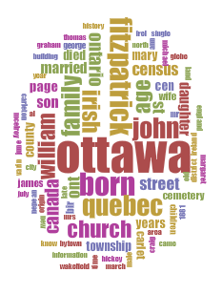

Who is Fitzpatrick? -Information may be irrelevant as they did not belong in the glebe

William Fitzpatrick was amember of the 100th Regiment of Foot, and settled in theGoulbourn area in the 1820s. Al Descendants ofWilliam Fitzpatrick Generation No. 1 1. WILLIAM2FITZPATRICK (UNKNOWN1) was born Abt. 1778 inUpperwood or Castlederry, County Leix, Ireland., and died Bef.1851 in Unknown.. He married MARY ANN (SEAMANS)SEMANS Bet. 1803 - 1810. She was born Abt. 1780 in Ireland.,and died May 31, 1878 in Alcove, Quebec. Notes for WILLIAMFITZPATRICK: William Fitzpatrick was born: 1778 (could alsobe 1768), and was a member of the British Army, 54th Regimentof Foot, 77th Regiment of Foot, and the 100th Regiment of Foot(later became the 99th Regiment of Foot), (recruited in Dublin in1804). He was in the British forces from about 1795 to 1816 (or1818), and retired at the age of 50. He was heavily involved inthe 1812-1814 War, and was a Sergeant, he was Quarter-Masterto the Regimental left-flank, was also regimental Pay-Master,and the Assistant Barrack Master at Fort Wellington, he was alsoappointed by Sir William Prevost to the position of full BarrackMaster at Fort Wellington, Prescott, Ontario

Word Trend : Irish

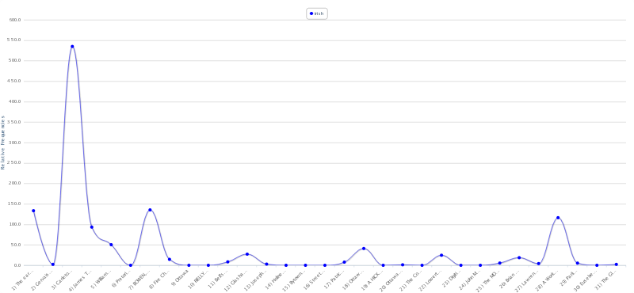

We know that:

With the news of the building of a canal came floods of workers from

all over the place. Irish immigrants and French-Canadians poured in

from Quebec, while stone masons under the leadership of [Thomas McKay](http://www.bytown.net/mckaythomas.htm)

were hired en masse from Scotland and brought to Bytown. Thomas McKay

immediately set up a settlement east of the Rideau, called New Edinburgh,

and brought over his workers and their families to live there. On the

other hand almost all the French-Canadians and Irish settled in Lowertown

(probably not out of choice, but rather dictated by their lack of money).

-These were probably low income families who were encouraged to come build the canal to make more money??

The first five years came up with : 2002-2006

http://voyant-tools.org/tool/Cirrus/?corpus=1427294122025.2879&stopList=stop.en.taporware.txt

* Shows Irish - again this was probably because it was mostly Irish settlers who settled in lower town (building the Rideau canal)
* Quebec came up - probably because the Irish immigrants came from Quebec

The last five years : 2010-2014

http://voyant-tools.org/tool/Cirrus/?corpus=1427294399518.9049&stopList=stop.en.taporware.txt

* Shows street probably because of Bank street is a popular shopping area with unique stores - also Lansdowne is opening with more stores - 2015
* building comes up - talks about coliseum. Cultural heritage value. however it was torn down in 2012